

Company Address:

Phone:

E-mail:

Date:

SERVICE CERTIFICATE
This is to certify that Mr. Ms. Sudha was employed by us and his particulars of
service are as under:

- Name : Ms. Sudha
- Designation : System Operator.
- Department : Administration.
- Last salary Drawn : Rs 15000/- per month
- Other Benefits : Benefits under Health Insurance Scheme variable Allowance
conveyance Allowance provident fund superannuation fund medical reimbursement
leave travel assistance special allowance
- Date of joining : January 10, 2017
- Date of Leaving : March 10, 2018
- Reason of leaving : Personal
- Conduct : Good
- Remarks : NA

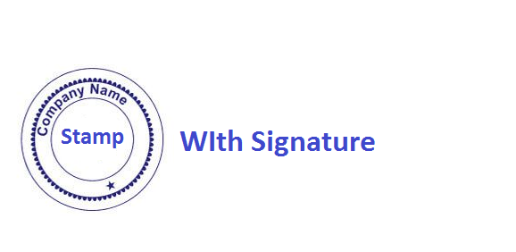
Director

Company Name

